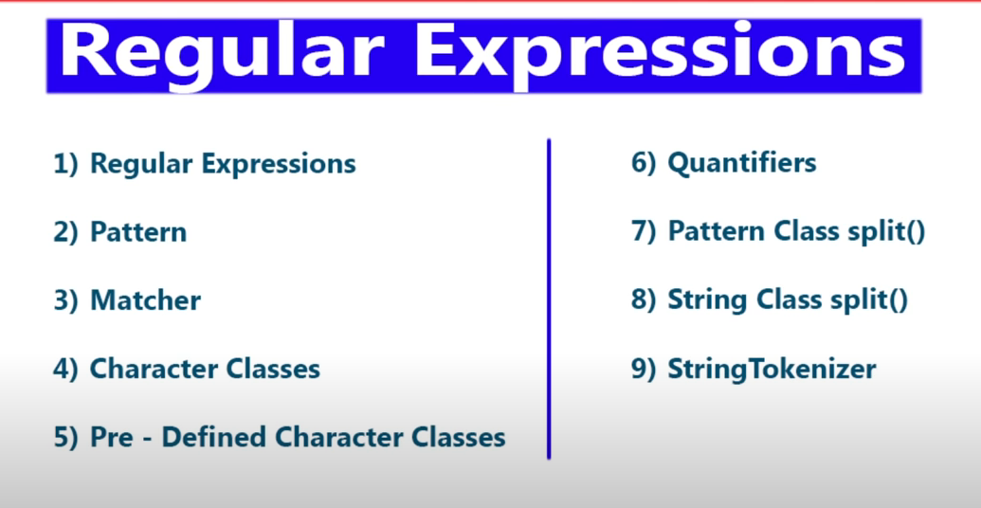

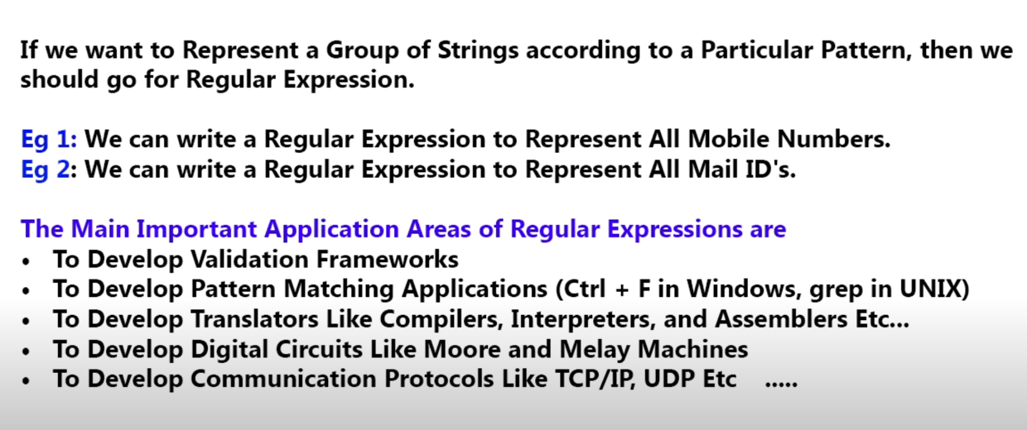

package program;

import java.util.regex.Matcher;

import java.util.regex.Pattern;

public class FindPatternInGivenString {

static int count =0;

public static void main(String[] args) {

Pattern p = Pattern.compile("ab");

Matcher m =p.matcher("ababbaba");

while(m.find()) {

count++;

System.out.println(m.start()+"...."+(m.end()-1)+"....."+m.group());

}

System.out.println(count);

}

}

